While loop

Python has two primitive loop commands:

* while loops
* for loops

The while Loop

With the while loop we can execute a set of statements as long as a condition is true.

Print i as long as i is less than 6:  
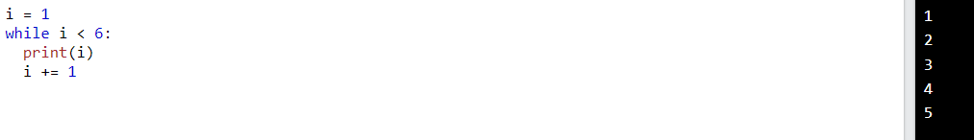  
The while loop requires relevant variables to be ready, in this example we need to define an indexing variable, i, which we set to 1.

The break statement

With the break statement we can stop the loop even if the while condition is true:

Exit the loop when i is 3:  
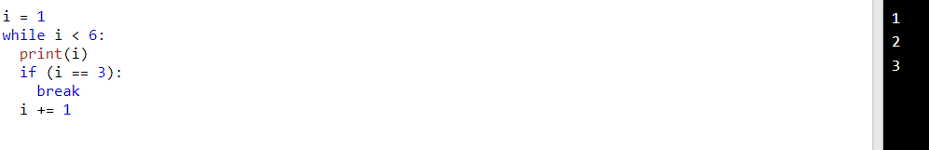

The continue statement

With the continue statement we can stop the current iteration, and continue with the next:

Continue to the next iteration if i is 3:  
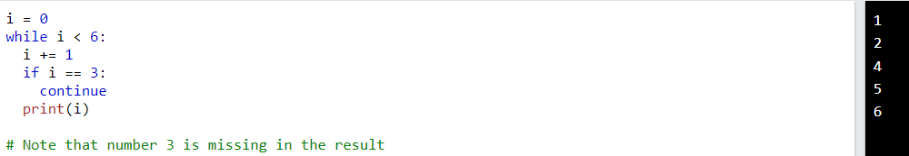

The else statement

With the else statement we can run a block of code once when the condition no longer is true:

Print a message once the condition is false:  
